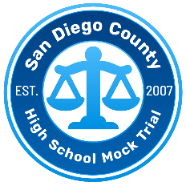
Please note: Witnesses may be called in a different order than what is listed.
2026 San Diego High School Mock Trial Competition
Prosecution Trial Team Lineup

School Code:

Instructions: Please fill out completely and click on box to include a photo of each student. Bring 6 copies to give to the Judges and Scorers before each trial.

Photo |  | Role |  | Student Name |  | Photo |  | Role |  | Student Name
 |  | Prosecution Pretrial Motion Attorney |  |  |  |  |  | Prosecution Witness  Detective  Rio Sacks
 |  | Prosecution  Attorney |  |  |  |  |  | Prosecution Witness  Contestant  Alden Mitchell
 |  | Prosecution  Attorney |  |  |  |  |  | Prosecution Witness  Expert  Sam Longo
 |  | Prosecution  Attorney |  |  |  |  |  | Prosecution Witness  First Assistant Director  Imari Rodriguez
 |  | Clerk

