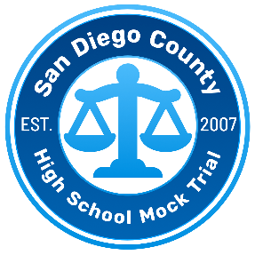
2025-2026
SAN DIEGO COUNTY HIGH SCHOOL MOCK TRIAL COMPETITION
TIMELINE
DATE | EVENT/ITEM | NOTES
September 5, 2025 | Case Brief Release
September 11, 2025 | Case Materials Release | Passcode Required
September 9, 2025  3:45 - 4:45 p.m. | Teacher Orientation Meeting | Held via Zoom - Link to Register
September 11, 2025  12:15 - 1:15 p.m. | Attorney Coach Orientation Meeting | Held via Zoom - Link to Register
September 11, 2025  3:45 - 4:45 p.m. | Teacher Orientation Meeting | Held via Zoom – Link to Register
September 16, 2025  5 - 6 p.m. | Attorney Coach Orientation Meeting | Held via Zoom - Link to Register
September 26, 2025 | Deadline for schools to register | Team Registration Form
September 26, 2025 | Deadline for returning and new  attorney coaches to register | Registration is mandatory for all participating attorney coaches  Attorney Coach Commitment Form
October 17, 2025 | Deadline to submit scholarship request application for registration fee waiver and/or transportation reimbursement | Scholarship Application Form
October 30, 2025  4:00 - 5:00 p.m. | Mock Trial Rules and Procedures Update Sessions  Mandatory meeting for at least one Teacher Sponsor and one Attorney Coach per team | Held via Zoom - Link to Register
November 5, 2025  4:00 - 5:00 p.m. |  | Held via Zoom – Link to Register
December 5, 2025 | Deadline to submit team payment &  Deadline for Student Participant Agreement Forms | Team Fee Payment Form  Student Participant Agreement Form
January 9, 2025 | Deadline for Team Rosters | Team Roster Form
DATE | EVENT/ITEM | NOTES
January & February 2026 | San Diego County High School  Mock Trial Competition Rounds | Round 1 – Thursday, Jan. 22  Round 2 – Wednesday, Jan. 28  Round 3 – Tuesday, Feb. 3  Round 4, Award Ceremony & Semifinal  – Saturday, Feb. 7
Tuesday, February 10 | San Diego County High School  Mock Trial Competition  Championship Round | Deadline to register for State Competition is Feb. 27
March 20-22 | California State High School Mock Trial Competition Finals | TBD
May 7-9 | National High School Mock Trial Championship | Des Moines, Iowa

