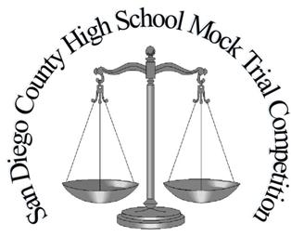
Please note: Witnesses might appear in a different order than they are listed on this roster.
2022 San Diego High School Mock Trial Competition
Prosecution Trial Team Roster

School Code:

Instructions: Please fill out completely and click on box to include a photo of each student. Bring 5 copies to give to the Judges and Scorers before each trial.

Photo |  | Role |  | Student Name |  | Photo |  | Role |  | Student Name
 |  | Prosecution Pretrial Motion Attorney |  |  |  |  |  | Prosecution Witness  Dr. Charlie Dunn
 |  | Prosecution  Attorney |  |  |  |  |  | Prosecution Witness  Deputy Sheriff Toni Garrett
 |  | Prosecution  Attorney |  |  |  |  |  | Prosecution Witness  Angel Russell
 |  | Prosecution  Attorney |  |  |  |  |  | Prosecution Witness  Terry Edwards |  | _____________________
 |  | Clerk

